Industrialization’s Effects Name__________________________

|  |
| --- |
| Was Industrialization good for the United States socially, politically, and economically? |

|  |  |  |
| --- | --- | --- |
|  | First 5 documents  Effects of industrialization described by this document & identify each issue as social (S), political (P), or economic (E) | Second 5 documents  Effects of industrialization described by this document & identify each issue as social (S), political (P), or economic (E) |
| Document 1 |  |  |
| Document 2 |  |  |
| Document 3 |  |  |
| Document 4 |  |  |
| Document 5 |  |  |

|  |
| --- |
| Was Industrialization good for the United States socially, politically, and economically? |

|  |  |
| --- | --- |
| **Position A:**  **Yes, Industrialization was good for the United States.** | **Position B:**  **No, Industrialization hurt the United States.** |
| Evidence 1: | Evidence 1: |
| Evidence 2: | Evidence 2: |
| Evidence 3: | Evidence 3: |
| Evidence 4: | Evidence 4: |

Now that you have the two sides; what is your group’s consensus?

(Answer in complete sentences)

____________________________________________________________________________________________________________________________________________________________________________________________________________________________________________________________________________________________________________________________________________________________________________________________________________________________________________________________________________________________________________________________________________________________________________________________________________________________________________________________________________________________________________________________________________________________________________________________________________________________________________________________________________________________________________________________________

Document 1

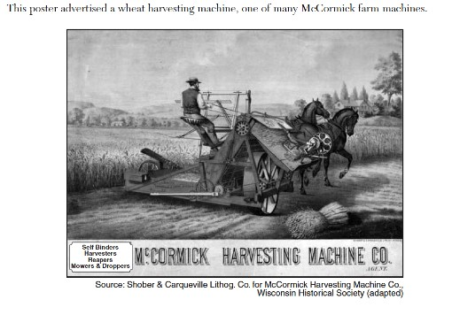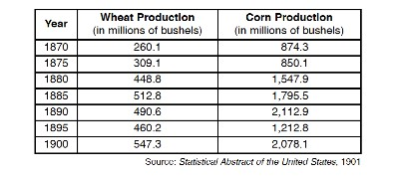

Document 2

. . . If you find it hard to believe that the Internet is merely a modern twist on a 19th-century system, consider the many striking parallels. For a start, the telegraph, like the Internet, changed communication completely. While the Internet can turn hours into seconds, the telegraph turned weeks into minutes. Before the telegraph, someone sending a dispatch to India from London had to wait months before receiving a reply. With the telegraph, communication took place as fast as operators could tap out Morse code.

**Source:** Tom Standage, “The 19th-Century Internet,”

Document 3

. . . Like information technology [IT] today, railroads in the second half of the 19th century promised to revolutionize society—shrinking distances, dramatically lowering costs, opening new markets, and increasing competition. Railroads were the great transformational technology of the age and promised to change everything…. Railroads did, in the end, deliver the revolution promised. Costs came down, living standards rose, markets expanded, and geography shrank. In fact, the railroad infrastructure, built with so much sweat, blood, and money a century ago, is still serving us today. . . .

**Source:** Barry Sheehy, “Train Wrecks: Why Information Technology Investments Derail,” *CPC Econometrics.*

Document 4

. . . The significance of the American entry into the conflict [World War I] was not at all a military one, at least for twelve to fifteen months after April 1917, since its army was even less prepared for modern [warfare] than any of the European forces…. But its productive strength … was unequaled. Its total industrial potential and its share of world manufacturing output was two and a half times that of Germany’s…. It could launch merchant ships in their hundreds, a vital requirement in a year when the U-boats were sinking over 500,000 tons a month of British and Allied vessels. It could build destroyers in the astonishing time of three months. It produced half of the world’s food exports….

In terms of economic power, therefore, the entry of the United States into the war quite transformed the balances, and more than compensated for the collapse of Russia at this same time…. the productive resources now arranged against the Central Powers were enormous….

**Source:** Paul Kennedy, The Rise and Fall of the Great Powers, Random House, 1987

Document 5

*Although they sometimes used controversial methods to accumulate wealth, many wealthy business leaders, such as Andrew Carnegie, John D. Rockefeller, and J. P. Morgan, also gave away millions of dollars. This excerpt describes some of the charitable work of Andrew Carnegie.*

….Carnegie had not forgotten his heritage of concern for social justice. In his 1889 article “Wealth,” he…proclaimed the moral duty of all possessors of great wealth to plow back their money into [charity] with the same judgment, zeal, and leadership they had devoted to getting rich. And he lived up to that precept [principle], paying for thousands of library buildings, setting up trusts and foundations, endowing universities, building Carnegie Hall in New York and the Peace Palace at The Hague, and much more. He once wrote that the man who dies rich dies disgraced.

**Source:** Foner and Garraty, eds., “Andrew Carnegie,” *The Reader’s Companion to American History,* Houghton Mifflin, 1991

Document 1

Meat scraps were also found being shoveled into [cans] from dirty floors, where they were left to lie until again shoveled into barrels or into machines for chopping. These floors, it must be noted, were in most cases damp and soggy, in dark, ill-ventilated rooms, and the employees in utter ignorance of cleanliness or danger to health expectorated [spit] at will upon them. In a word, we saw meat shoveled from filthy wooden floors, piled on tables rarely washed, pushed from room to room in rotten box carts, in all of which processes it was in the way of gathering dirt, splinters, floor filth, and the expectoration [spitting] of tuberculosis and other diseases.

Where comment was made to floor superintendents about these matters, it was always the reply that this meat would afterwards be cooked, and that this sterilization would prevent any danger from its use….

In one well-known establishment we came upon fresh meat being shoveled into barrels, and a regular proportion being added of stale scraps that had lain on a dirty floor in the corner of a room for some days previous.

**Source**: Upton Sinclair, *The Jungle*, 1902

Document 2

First let me tell you something about the way we work and what we are paid….The regular work pays about $6 a week and the girls have to be at their machines at 7 o'clock in the morning and they stay at them until 8 o'clock at night, with just one-half hour for lunch in that time.

The shops. Well, there is just one row of machines that the daylight ever gets to – that is the front row, nearest the window. The girls at all the other rows of machines back in the shops have to work by gaslight, by day as well as by night.

The shops are unsanitary—that's the word that is generally used, but there ought to be a worse one used. Whenever we tear or damage any of the goods we sew on, or whenever it is found damaged after we are through with it, whether we have done it or not, we are charged for the piece and sometimes for a whole yard of the material.

At the beginning of every slow season, $2 is deducted from our salaries. We have never been able to find out what this is for.

Source: “Life in the Shop” by Clara Lemlich (1909)

Document 3

Hamlin Garland visited Homestead, Pennsylvania, and the Carnegie steel mills to write this article for *McClure’s Magazine*.

. . .The streets of the town were horrible; the buildings were poor; the sidewalks were sunken, swaying, and full of holes, and the crossings were sharp-edged stones set like rocks in a river bed. Everywhere the yellow mud of the street lay kneaded into a sticky mass, through which groups of pale, lean [thin] men slouched in faded garments [clothes], grimy with the soot and grease of the mills [factories]. The town was as squalid [dirty] and unlovely as could well be imagined, and the people were mainly of the discouraged and sullen [unhappy] type to be found everywhere where labor passes into the brutalizing stage of severity.

**Source:** Hamlin Garland, “Homestead and Its Perilous Trades–Impressions of a Visit,” McClure’s Magazine, June 1894

Document 4

*In 1914, according to the Commission on Industrial Relations, 35,000 workers were killed in industrial accidents and 700,000 injured. This is an interview between a government official and the owner of a Colorado coal company.*

Government: If a worker loses his life, are his dependents compensated [given money] in any way?

Coal Company: Not necessarily. In some cases they are and in some cases not.

Government: If he is crippled for life is there any compensation [money given]?

Coal Company: No sir, there is none….

Government: Then the whole burden [responsibility] is thrown directly upon their shoulders.

Coal Company: Yes, sir.

Government: The industry bears [carries] none of it?

Coal Company: No, the industry bears none of it.

**Source**: “Hearings of the Commission on Industrial Relations,” 1914

Document 5

*This cartoon depicts John Rockefeller, a powerful owner in the oil industry. The term “trust giant” refers to a business leader with almost total control over the industry of a certain product. Think about what the buildings in this cartoon represent and what the cartoonist is saying about Rockefeller’s power.*

**THE TRUST GIANT’S POINT OF VIEW,**

**“What a Funny Little Government”**



**Source:** Horace Taylor, *The Verdict,* January 22, 1900 (adapted).